**EXPRIMENT NO-4**

**CSA1142-OBJECT ORIENTED ANALYSIS AND DESIGN**

**ONLINE STOCK MANAGEMNENT SYSTEM**

**USE CASE DIGRAM**

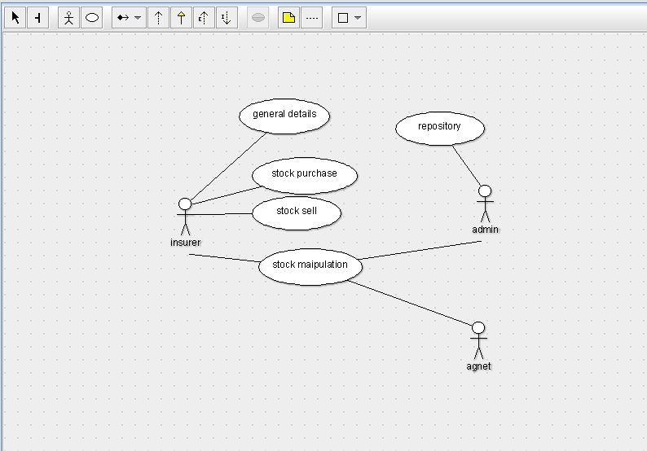

**CLASS DIGRAM**

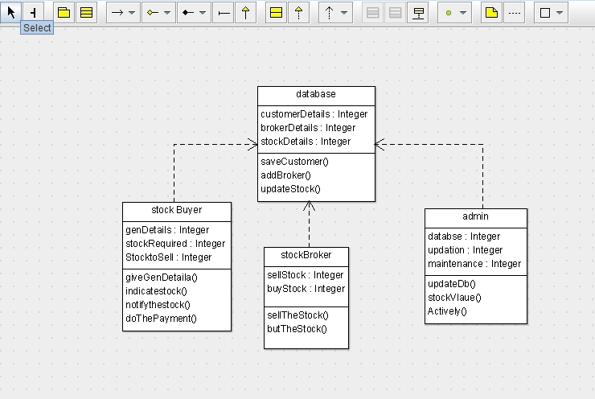

**STATE DIGRAM**

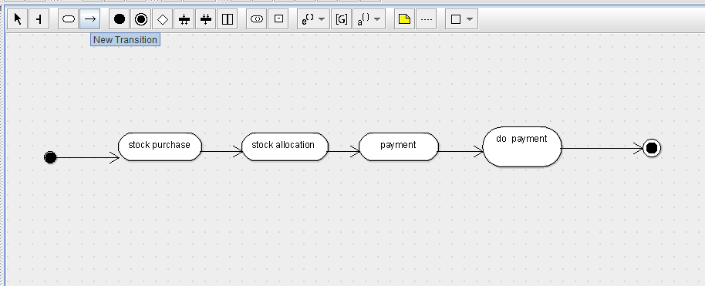

**SEQUENCE DIGRAM**

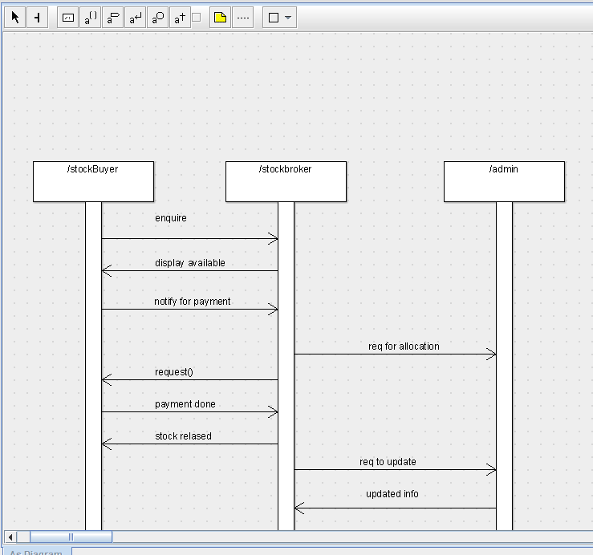

**DEPLOYMENT DIGRAM**

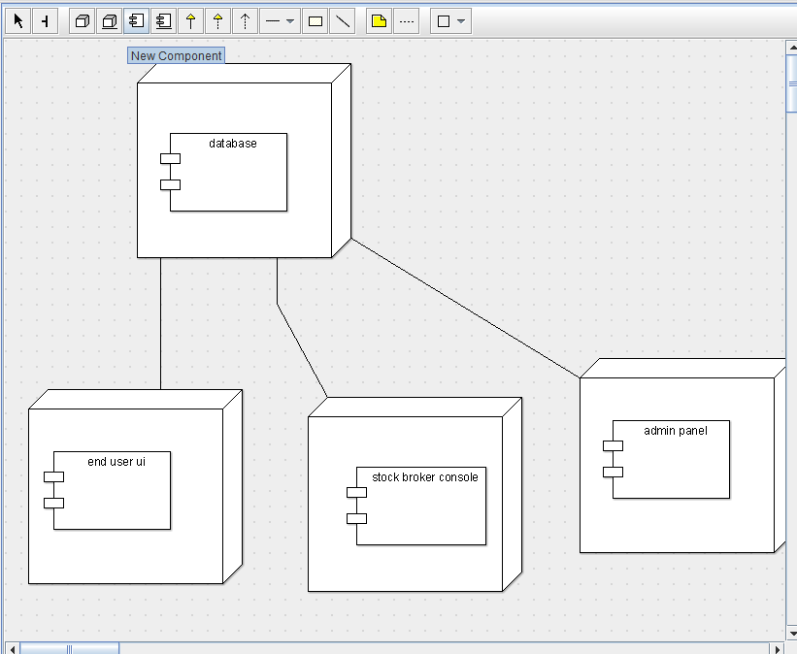

**COMPONENT DIGRAM**

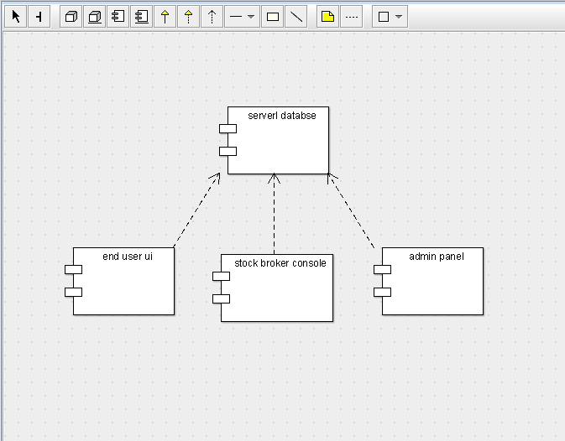

**COLLABRATION DIGRAM**

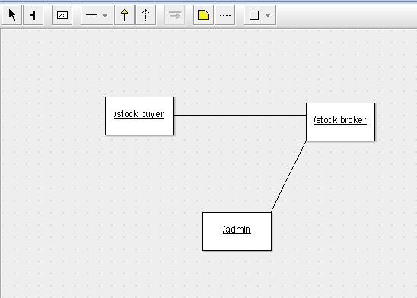

**ACTIVITY DIGRAM**

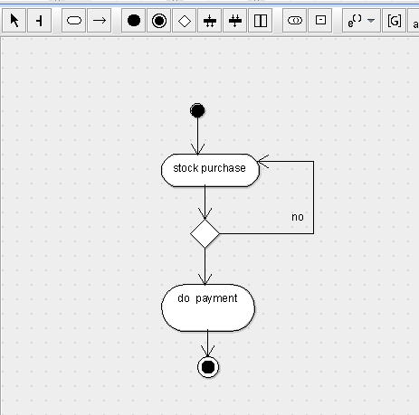

**SKELETON CODE:**

public class admin {

public Integer databse;

public Integer updation;

public Integer maintenance;

public void updateDb() {

}

public void stockVlaue() {

}

public void Actively() {

}

}

**public class database {**

**public Integer customerDetails;**

**public Integer brokerDetails;**

**public Integer stockDetails;**

**public void saveCustomer() {**

**}**

**public void addBroker() {**

**}**

**public void updateStock() {**

**}**

**}**

**public class stock Buyer {**

**public Integer genDetails;**

**public Integer stockRequired;**

**public Integer StocktoSell;**

**public void giveGenDetaila() {**

**}**

**public void indicatestock() {**

**}**

**public void notifythestock() {**

**}**

**public void doThePayment() {**

**}**

**}**

**public class stockBroker {**

**public Integer sellStock;**

**public Integer buyStock;**

**public void sellTheStock() {**

**}**

**public void butTheStock() {**

**}**

**}**